To: Andrew Danowitz

From: Soma Roy

Date: May 18, 2020

Re: Analysis of data predicting belief in graduating in engineering

**Examples of analysis:**

* The response is the probability that student agrees or strongly agrees that will believe they will graduate in engineering

**Comparing public to private schools**

* Higher odds of student saying agree or strongly agree that will believe they will graduate in engineering comparing those in public to those in private schools, although not at all a significant difference (0.664)

**R output**

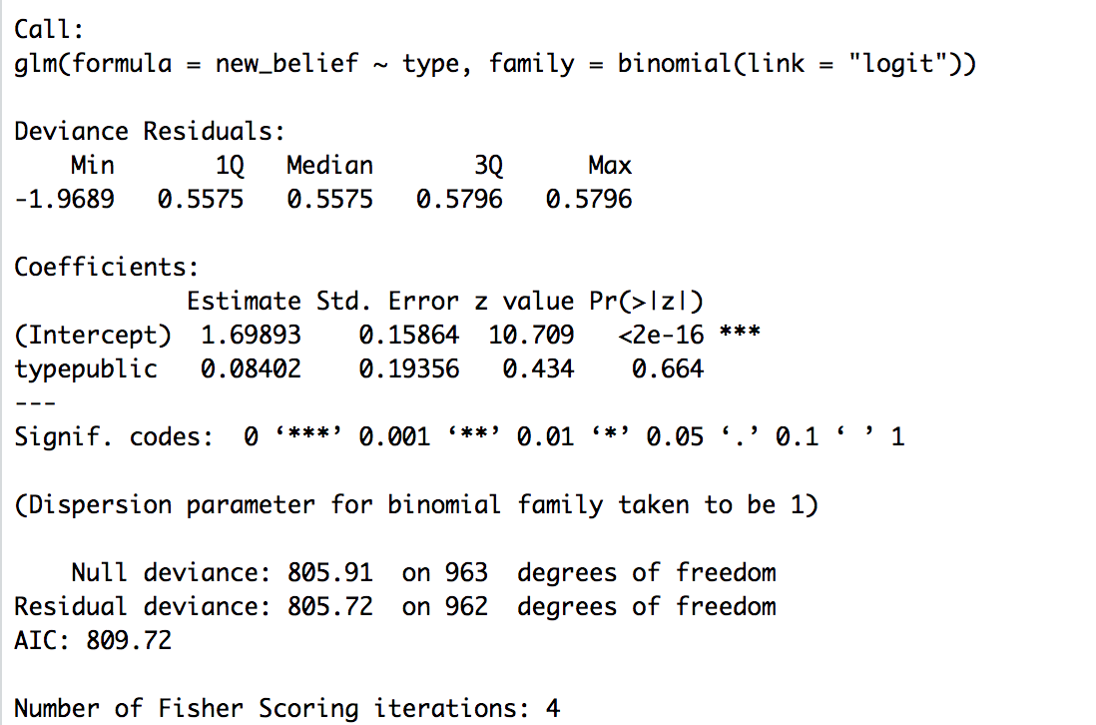

**Odds ratios**

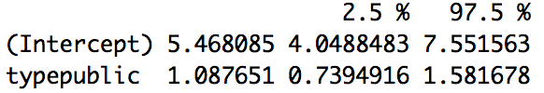

**R code (also provided as R script)**

